4/13/2020

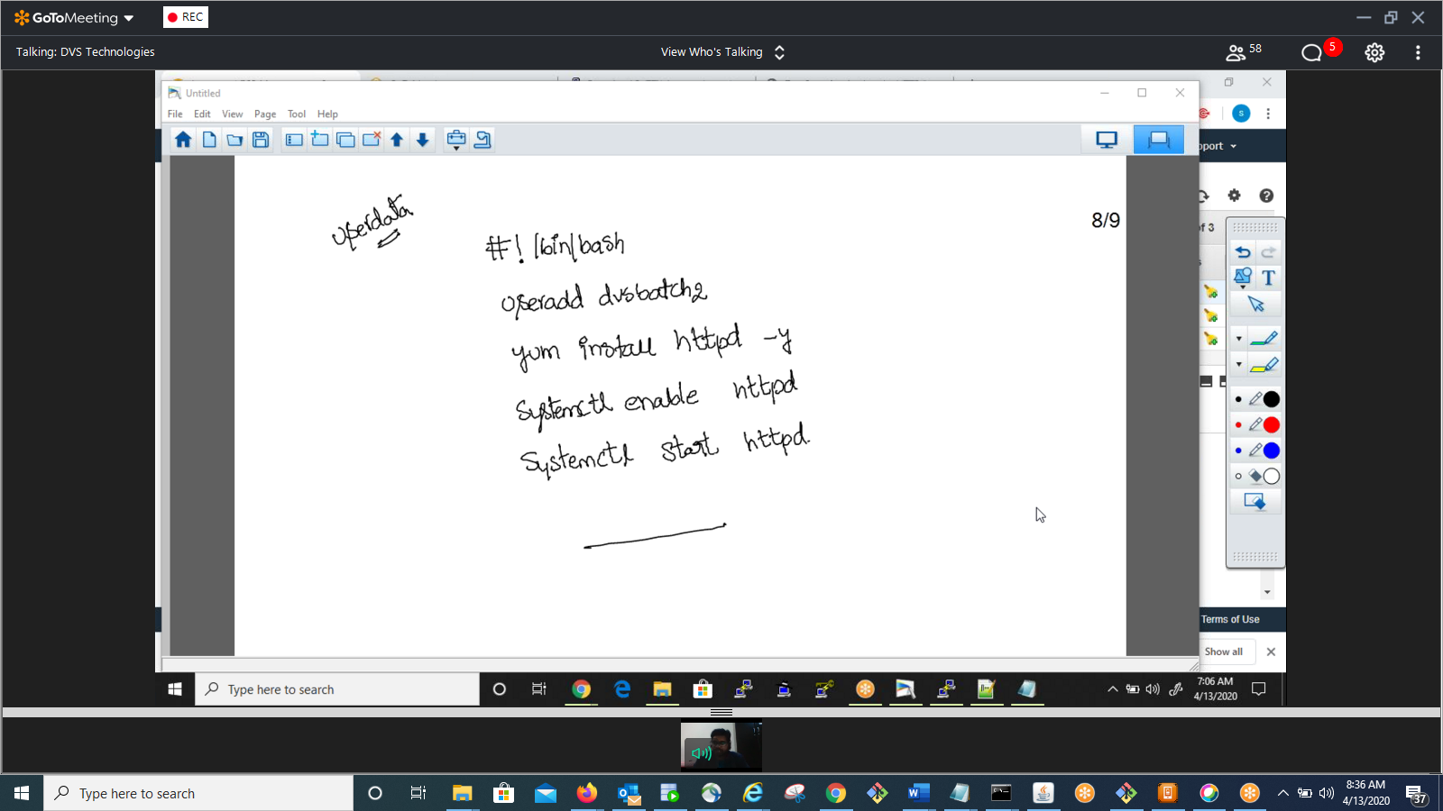

#!/bin/bash  
useradd dvsbatch2  
yum install httpd -y  
systemctl enable httpd  
systemctl start httpd

To check size of disk:

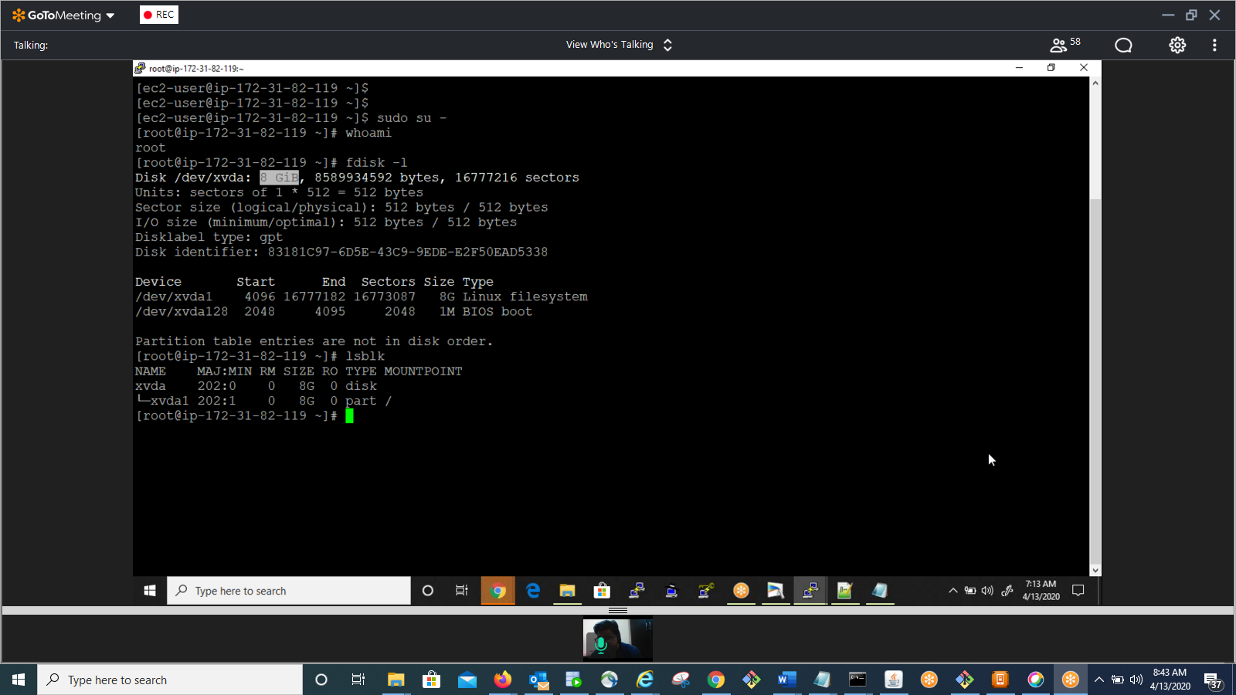

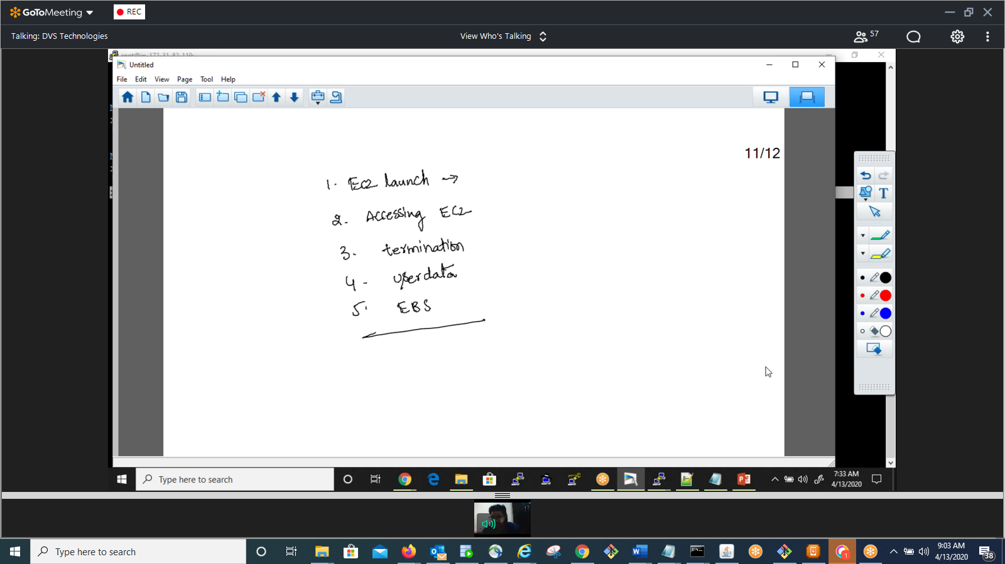

#!/bin/bash  
useradd prasanth  
mkdir /hom/prasanth/.ssh  
echo "Mykey" /hom/prasanth/.ssh/authorized_keys

user1_key="key1"  
user2_key2="key2"  
user2_key3="key3"  
for i in user1 user2 user3  
do  
useradd $i  
mkdir $i/.ssh  
echo $i_key > $i/.ssh/authorized_keys  
done

15th April

Topics:

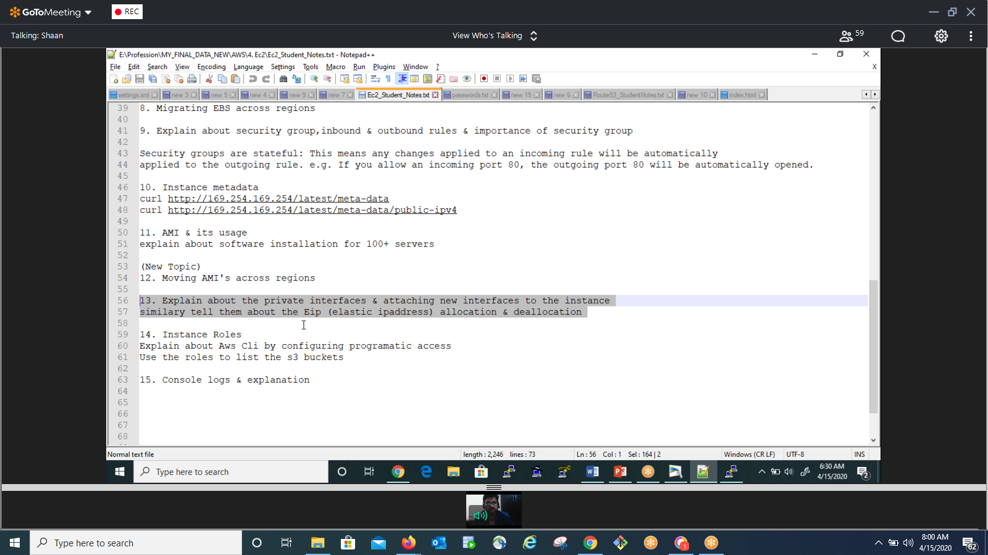

VPC Endpoint:

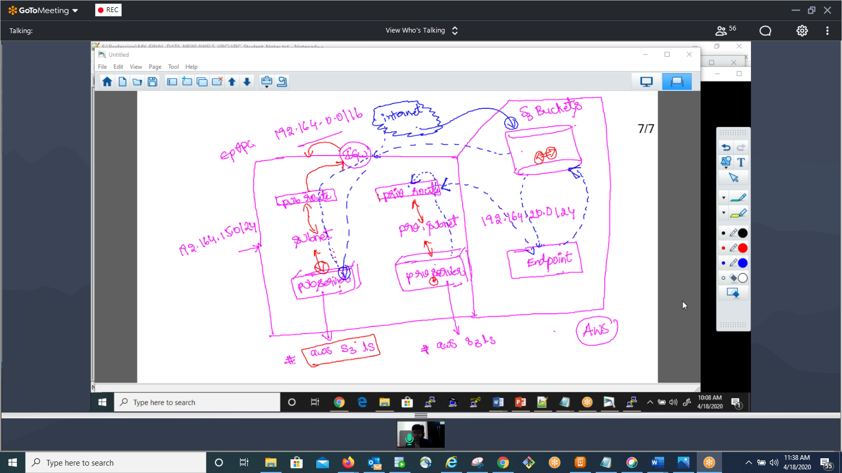

NACL

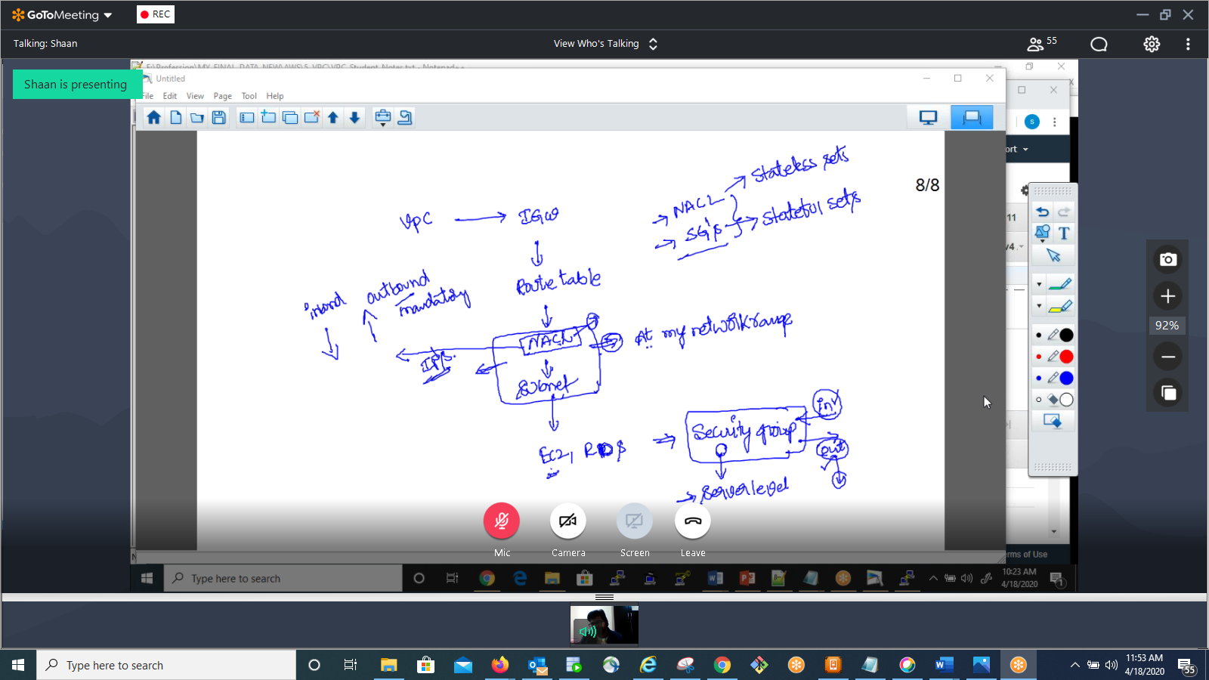

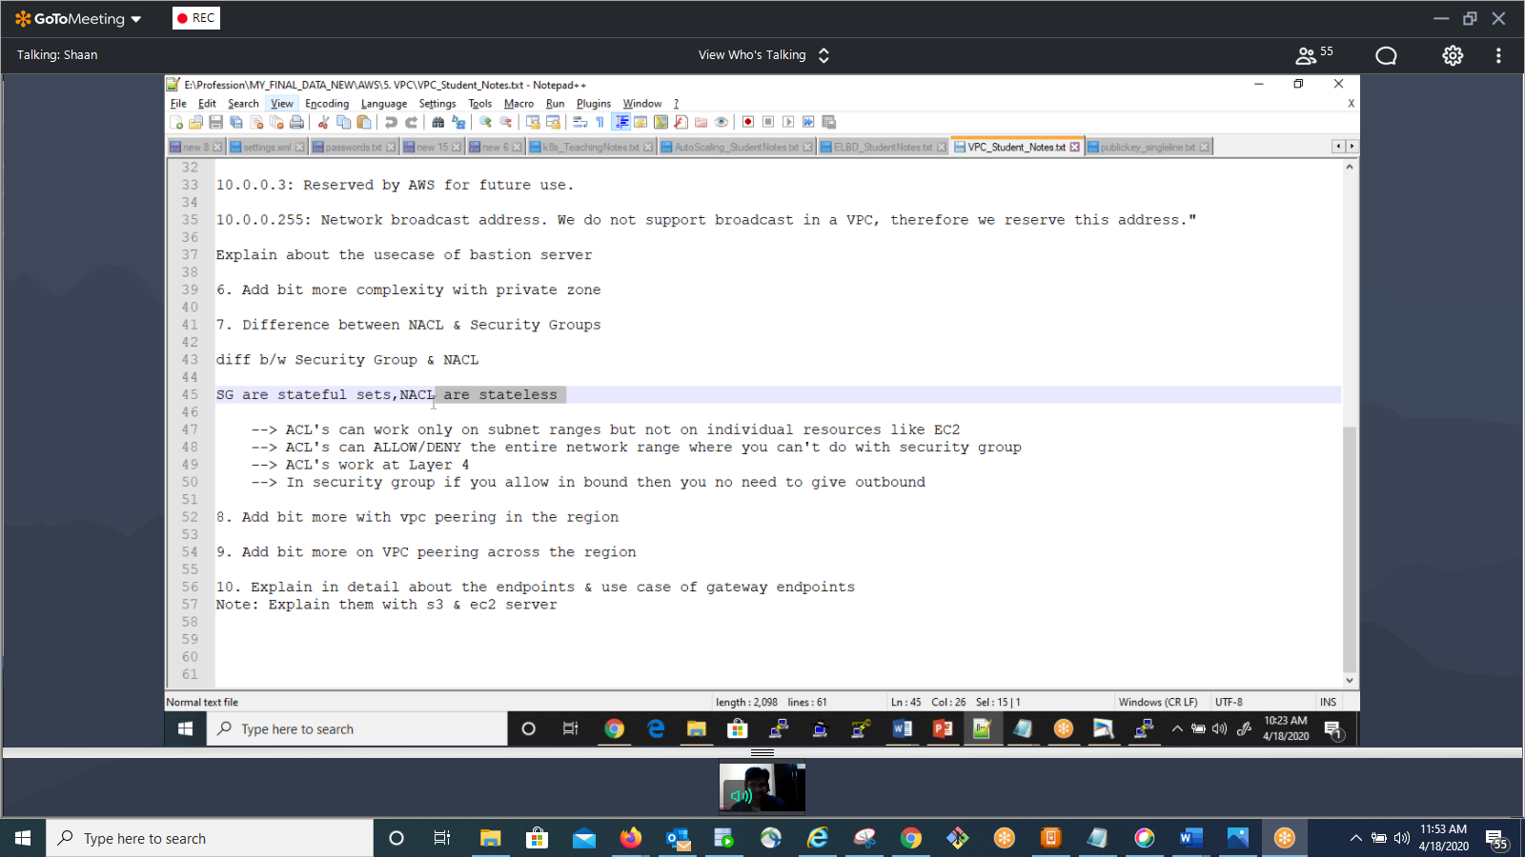

RDS:

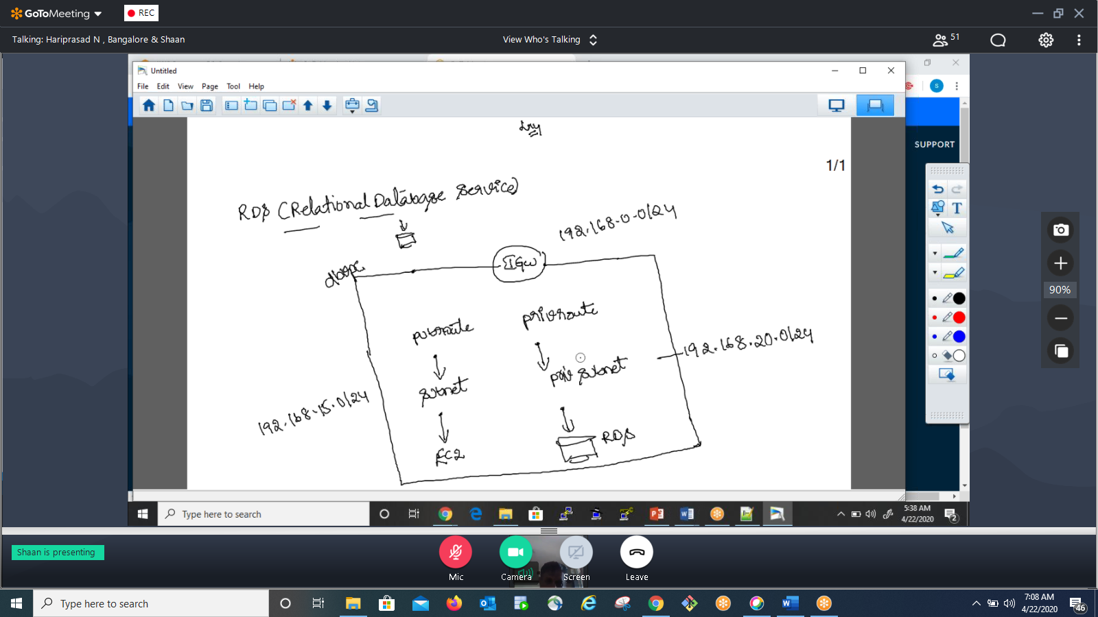

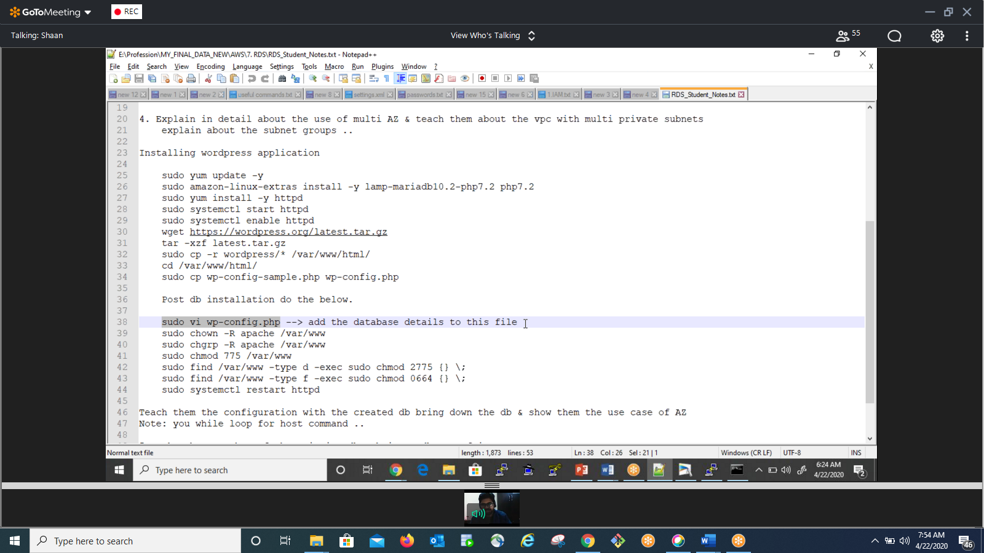

Installing wordpress application   
  
 sudo yum update -y  
 sudo amazon-linux-extras install -y lamp-mariadb10.2-php7.2 php7.2  
 sudo yum install -y httpd  
 sudo systemctl start httpd  
 sudo systemctl enable httpd  
 wget <https://wordpress.org/latest.tar.gz>  
 tar -xzf latest.tar.gz  
 sudo cp -r wordpress/* /var/www/html/  
 cd /var/www/html/  
 sudo cp wp-config-sample.php wp-config.php  
  
 Post db installation do the below.  
  
 sudo vi wp-config.php --> add the database details to this file  
 sudo chown -R apache /var/www  
 sudo chgrp -R apache /var/www  
 sudo chmod 775 /var/www  
 sudo find /var/www -type d -exec sudo chmod 2775 {} \;  
 sudo find /var/www -type f -exec sudo chmod 0664 {} \;  
 sudo systemctl restart httpd

23/4/20

Route 53: DNS

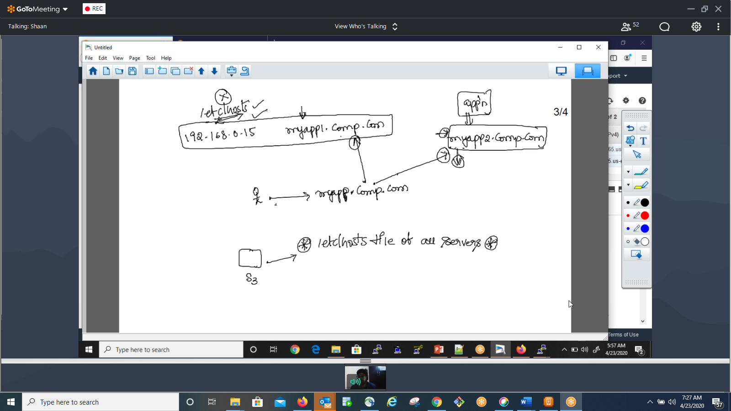

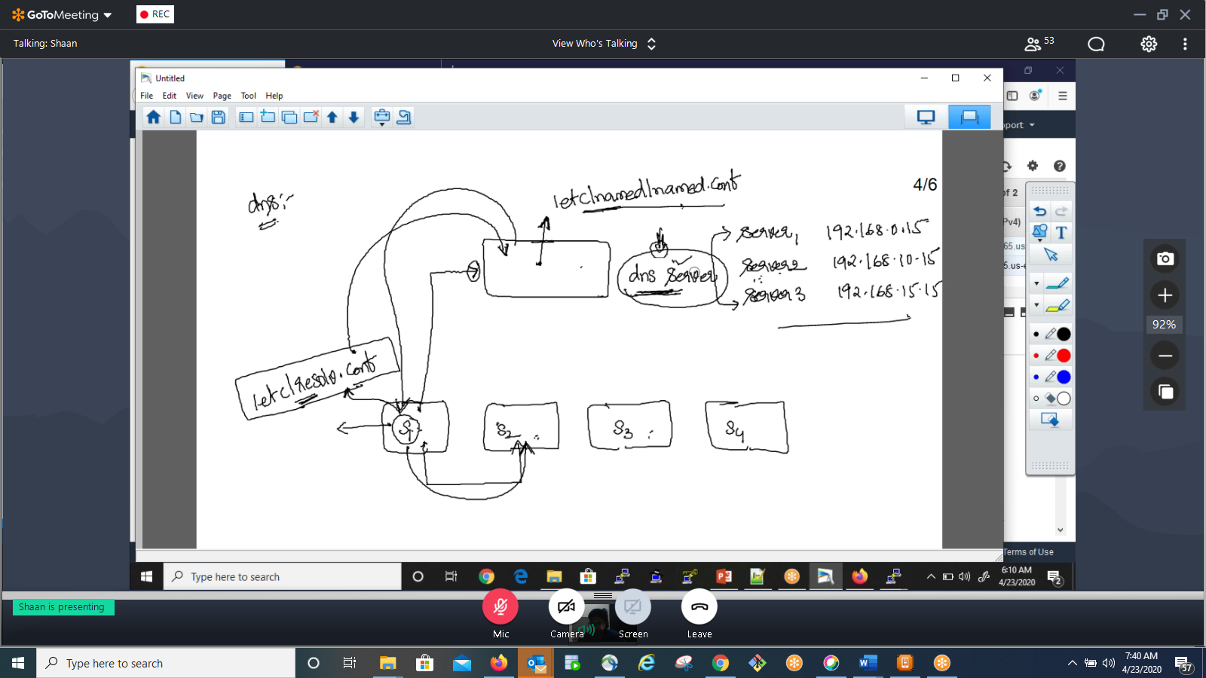

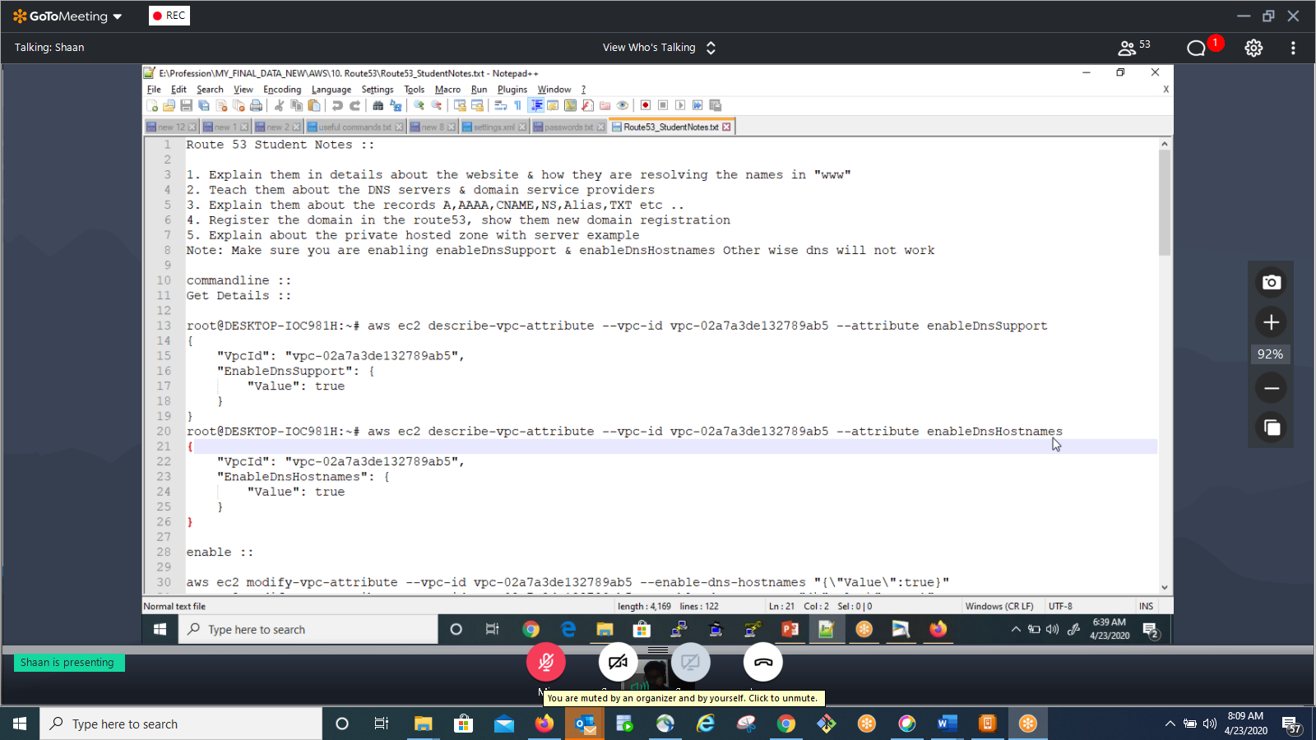

Access DNS through 3rd party vendor:

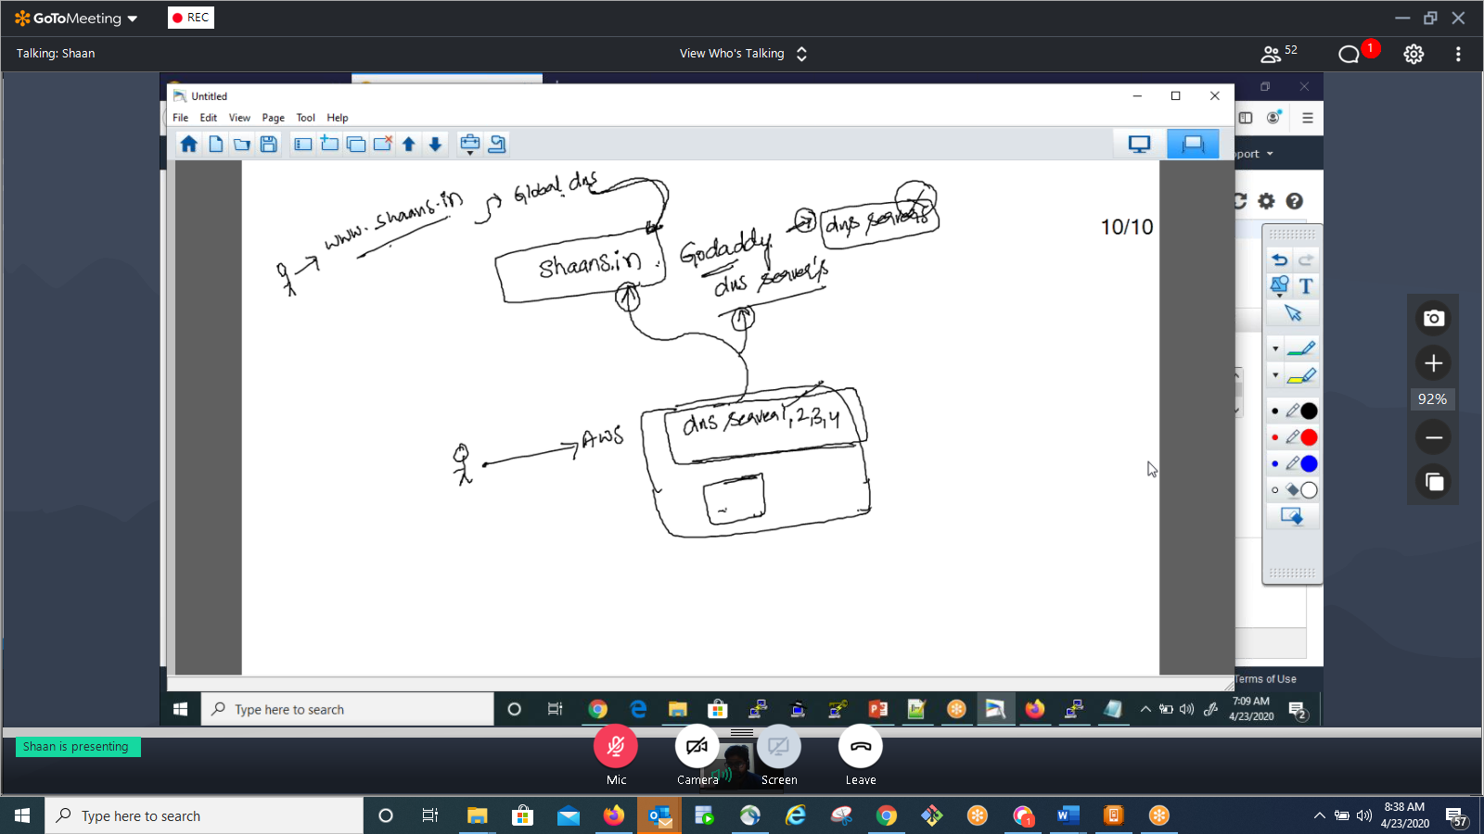

24/4

Routing policy:

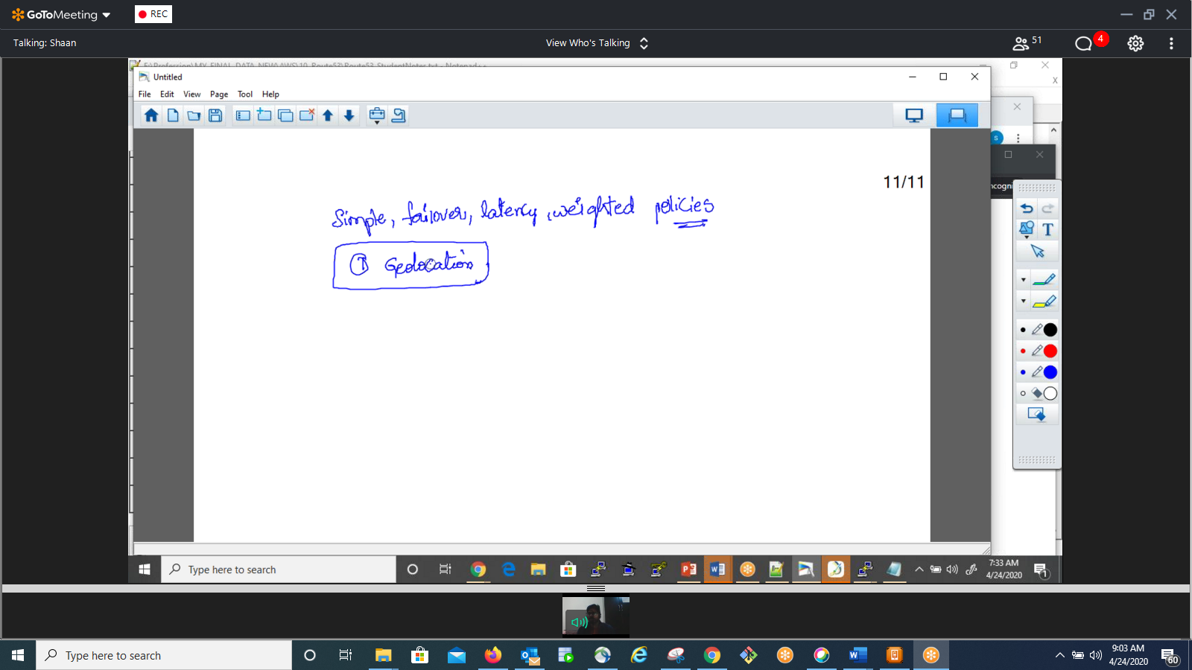

Load Balancer:

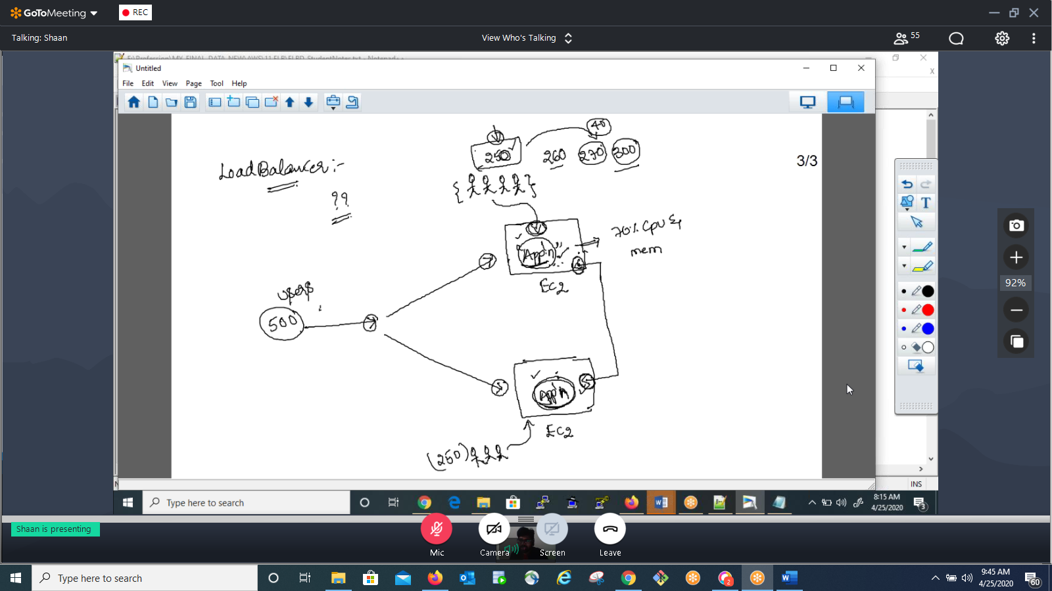

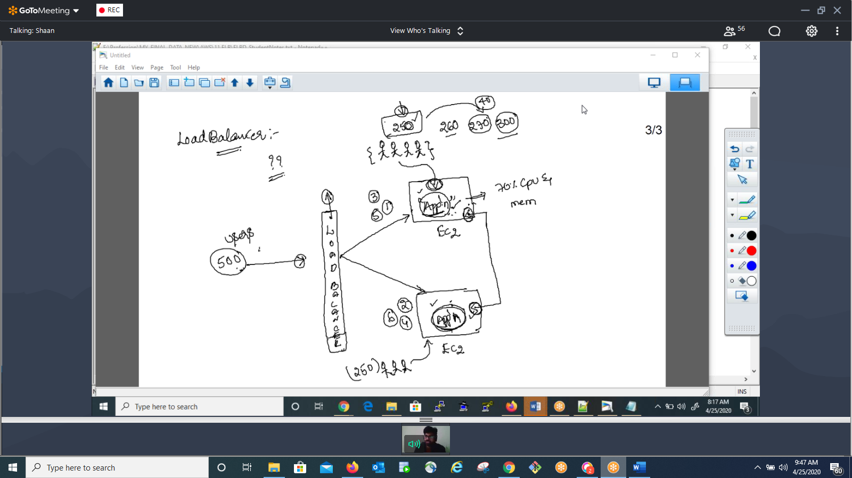

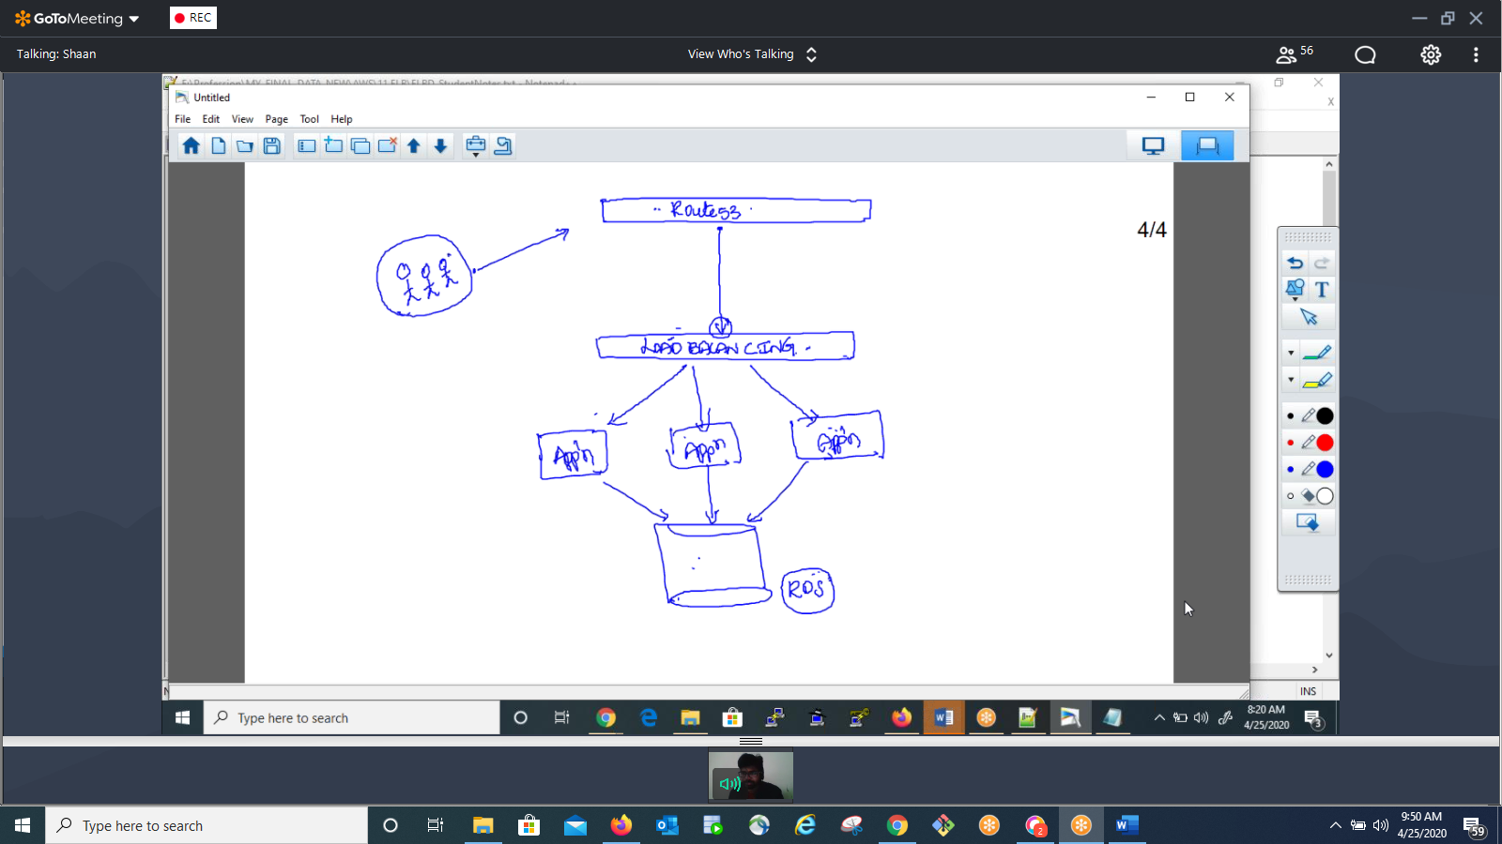

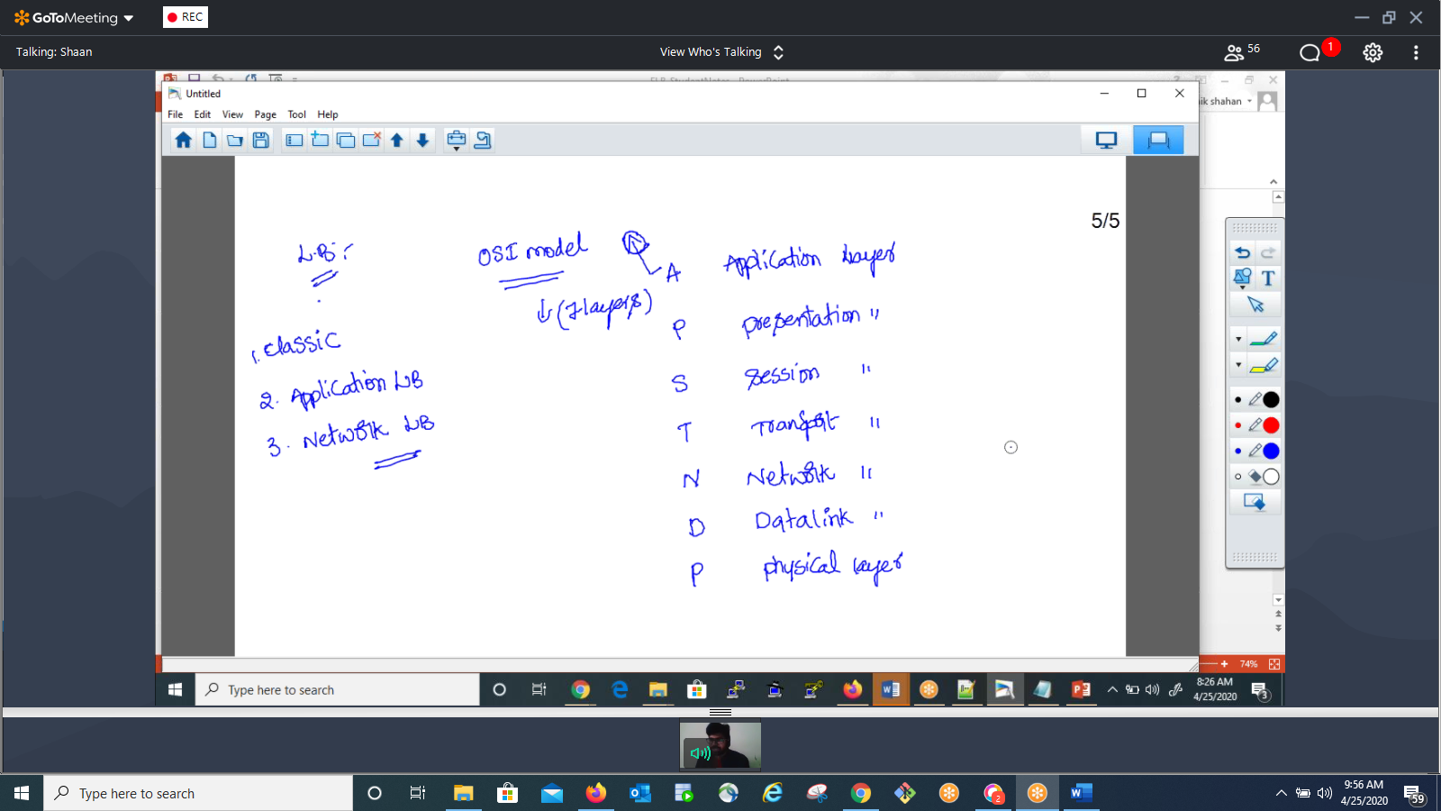

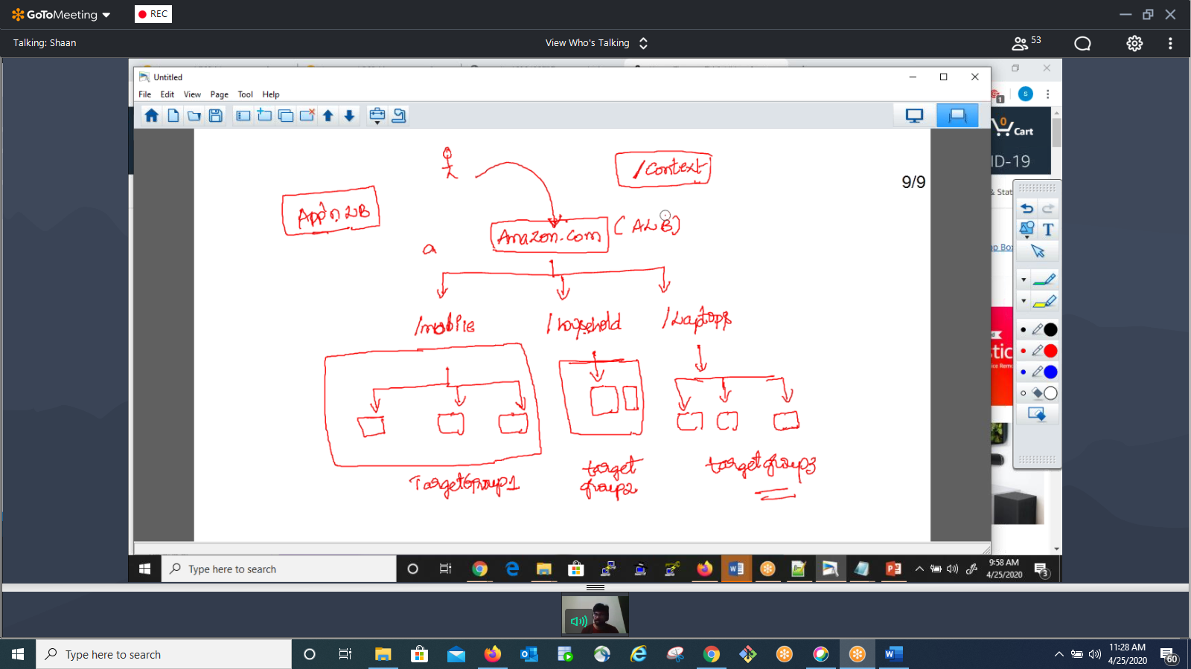

Command to rename the host name:

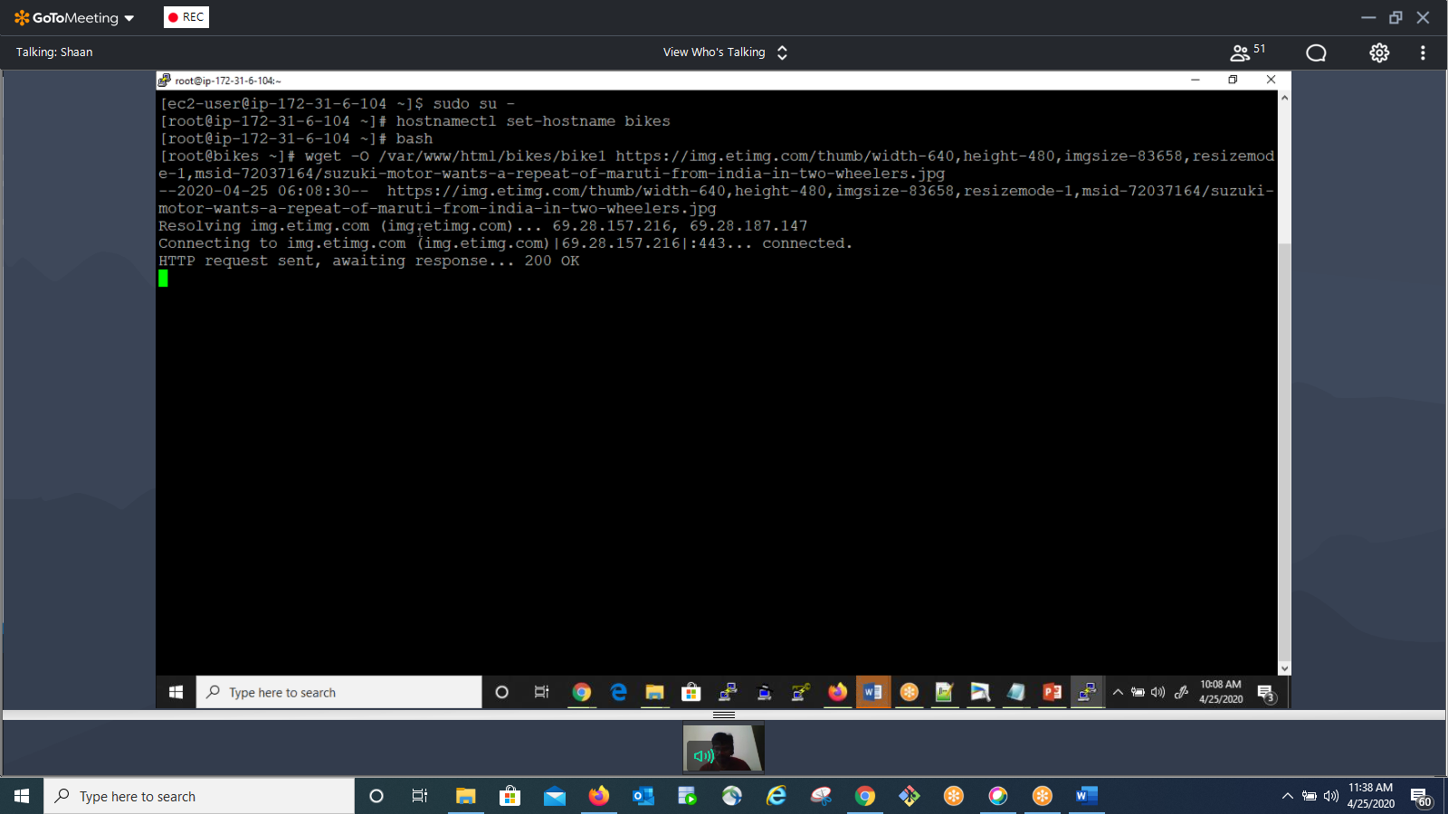

<https://cloudpingtest.com/aws>